The following shows example images, supplied by the Department for Levelling Up, Housing and Communities, of some of the most common forms of accepted photographic ID held by electors. This list is not exhaustive and there are other forms of photographic ID that are not included here.

International travel  Passports issued by the UK, any of the Channel Islands, the Isle of Man, a British Overseas Territory, an EEA state or a Commonwealth country (including an Irish passport card). | Driving and Parking  Driving licence issued by the UK, any of the Channel Islands, the Isle of Man, or an EEA state (this includes a provisional driving licence).
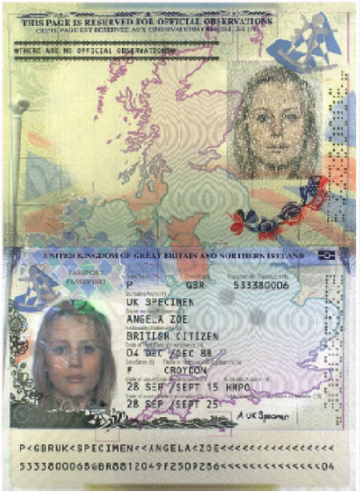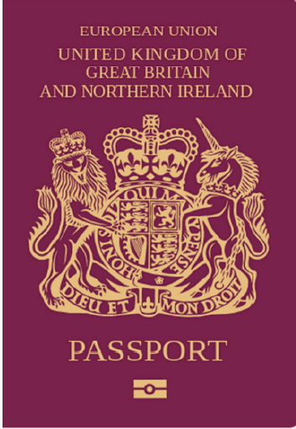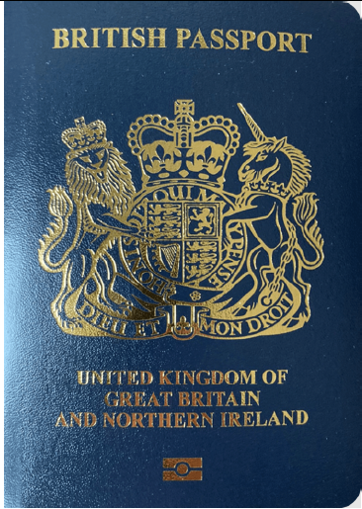 | 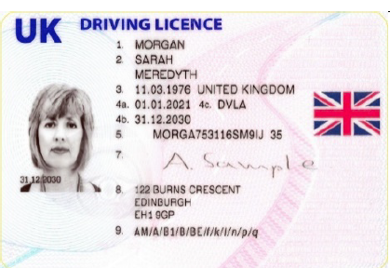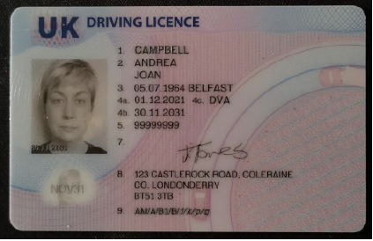  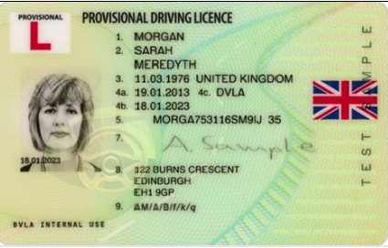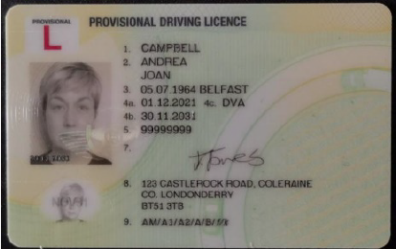
Blue Badge | Proof of age  Identity card bearing the Proof of Age Standards Scheme hologram (a PASS card).
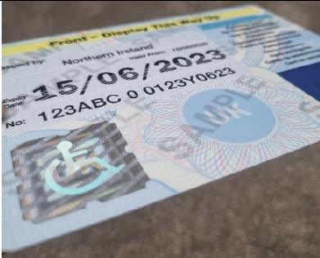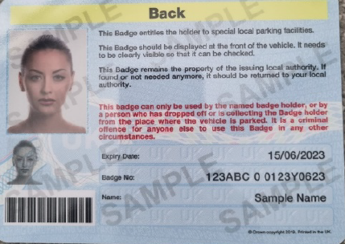 | 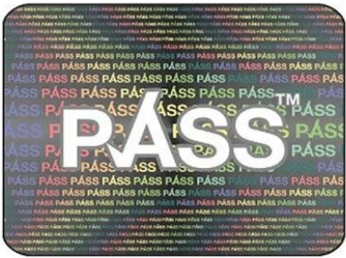

Local travel
Older Person’s Bus Pass | Disabled Person’s Bus Pass | Oyster 60+ Card
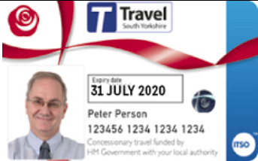 | 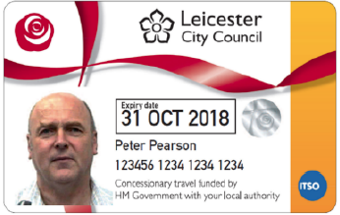 | 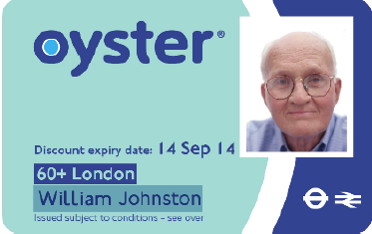
Freedom Pass | Scottish National Entitlement Card | 60 and Over Welsh Concessionary Travel Card
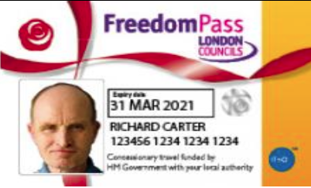 | 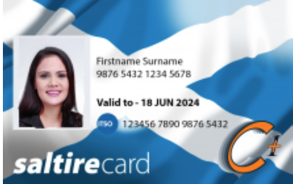 | 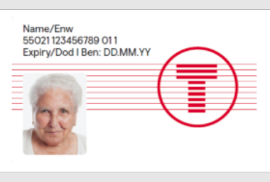
Disabled Person’s Welsh Concessionary Travel Card | Senior SmartPass issued in Northern Ireland | Registered Blind SmartPass or Blind Person’s SmartPass issued in Northern Ireland
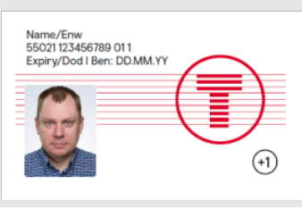 | 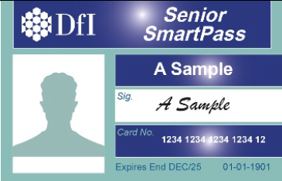 | 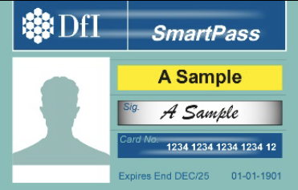
War Disablement SmartPass issued in Northern Ireland | 60+ SmartPass issued in Northern Ireland | Half Fare SmartPass issued in Northern Ireland
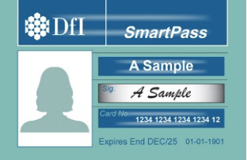 | 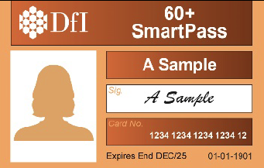 | 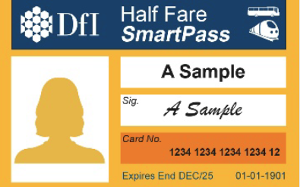
Other government issued documents
Biometric immigration document | Ministry of Defence Form 90 (Defence Identity Card)
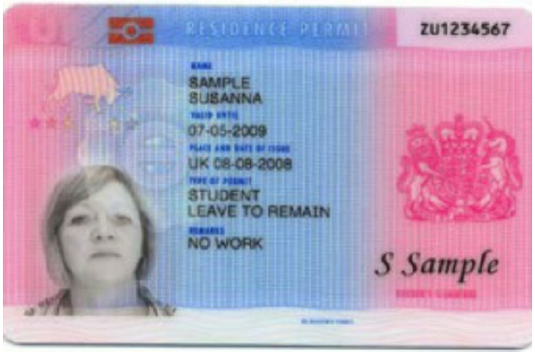 | 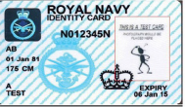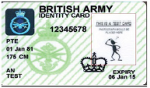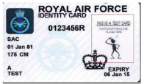

Electoral Identity Card issued in Northern Ireland | Voter Authority Certificate
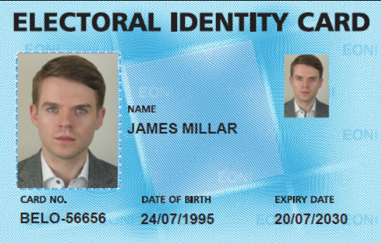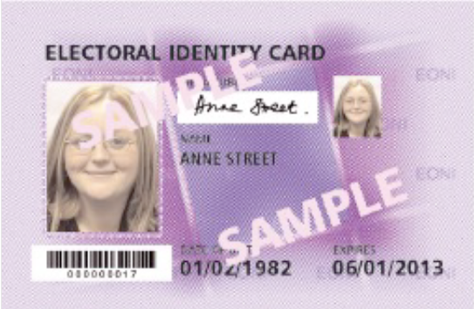 | 