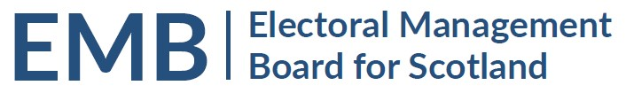Agenda
2pm Friday 2 December 2022
Meeting via Teams

MEETING ADMIN
- Apologies
- Previous Meeting 5 October 2022 (circulated)
EMB WORK PROGRAMME
- Scottish Local Government elections May 2022
  - Candidate Survey – circulated or available here
- eCount at Local Government by-elections 2022-27 - circulated
- EMB Future Work Programme
  - Follow up actions from the SLGE 2022 by EMB – circulated
  - Accessibility – oral update
  - Implementation of UK Elections Act 2022 – oral update
  - Coordination of observation visits to English elections in May 2023 – oral update
  - Capacity building in the sector / Proposed RO/ERO Seminar for 2023 – oral update
  - Development of the EMB – to follow
- Referendum Guidance– circulated
GENERAL UPDATES
- Scottish Government General Update – to follow
  - Scottish Government Electoral Reform Consultation – oral update
- UK Government – Department for Levelling Up, Housing and Communities: Elections and Registration Update
    - UK Funding Working Group – circulated
- Electoral Commission General Update – circulated
  - UK Public Administration and Constitutional Affairs Committee report on the work of the Electoral Commission - to note
- Electoral Registration Update from the Electoral Registration Committee of the SAA update - to follow
- AEA update circulated
- Boundaries Issues
  - 2023 Review of UK Parliamentary Boundaries, Revised Proposals – press release circulated
INFORMATION
- EMB Admin
  - Membership – future vacancy to note
  - Annual Report – to follow
- Log of by-elections - circulated
- Any Other Business
DATES OF FUTURE MEETINGS
25 January 2023
30 March 2023
Further dates to be agreed

