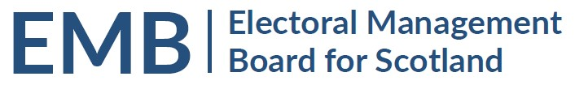Agenda
11.30 Wednesday 5 October 2022
Meeting via Teams

MEETING ADMIN
- Apologies
- Previous Meeting 28 April 2022 (brief update meeting, no note of meeting)
EMB WORK PROGRAMME
- Scottish Local Government Elections 5 May 2022
  - Review of feedback from Returning Officer Teams – circulated
  - eCount Lessons Learned – to follow
- Electoral Commission Report on the May 2022 Scottish Council Elections - circulated
- EMB Future Work Programme
  - Implementation of UK Elections Act 2022 – oral update
  - Preparation for unscheduled electoral events
  - Funding of Elections
    - UK Funding Working Group – update slides circulated
    - Scottish Government Funding review
  - Proposed RO/ERO Seminar for 2023
- Scottish Government Consultation on Electoral Reform and the Future of the EMB
  - Response to Minister and comments on proposed topics – circulated
GENERAL UPDATES
- Scottish Government General Update – to follow
- UK Government – Department for Levelling Up, Housing and Communities: Elections and Registration Update
- Electoral Commission General Update – oral update
- Electoral Registration Update from the Electoral Registration Committee of the SAA update to follow
- AEA update to follow
- Boundaries Issues
  - Second Review of Parliamentary Boundaries – press release circulated
INFORMATION
- EMB Admin
  - Membership
  - Finance
  - Annual Report
- Log of by-election - circulated
- Any Other Business
DATES OF FUTURE MEETINGS
2 December 2022
25 January 2023
30 March 2023
Further dates to be determined

