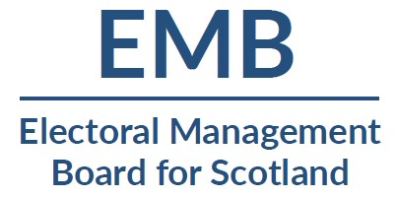

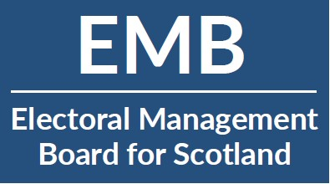
Design uses a straightforward typographical design using font Lato which is clean, modern, no fuss and has great legibility. Widely available for both Mac and PC users

This option focuses on initials EMB which is currently how people refer to the organisation. Focusing on initials gives logo more of an identity rather than just being a sentence (as it’s quite a long name). Design works as a horizontal and also a stacked option which gives flexibility in how it could be used.

Dark blue seems obvious choice of colour to reflect Scotland, trustworthiness and again great for legibility.

